TUTORIAL - Business Process Modelling and Enterprise Architecture & Advance Information System Development

Introduction to BPMN Gateways

Aim: The aim of this tutorial is to explore the different types of BPMN Gateways, such as Exclusive OR, Inclusive OR, Parallel and Complex Gateway and to apply and distinguish their use in the context of a simple “cook meal” scenario.
Background: The following BPMN diagram models a simple “cook meal” process, which uses an XOR gateway for selecting the desired dish of the process. Examine the diagram to identify the alternative routes that a token may take.

Part 01

Each one of the following tasks require you to improve this original diagram, in order to address more complex processes as specified in the tasks. Answers to the tasks will be made available as we progress with the tutorial to help you answer the more complex processes.

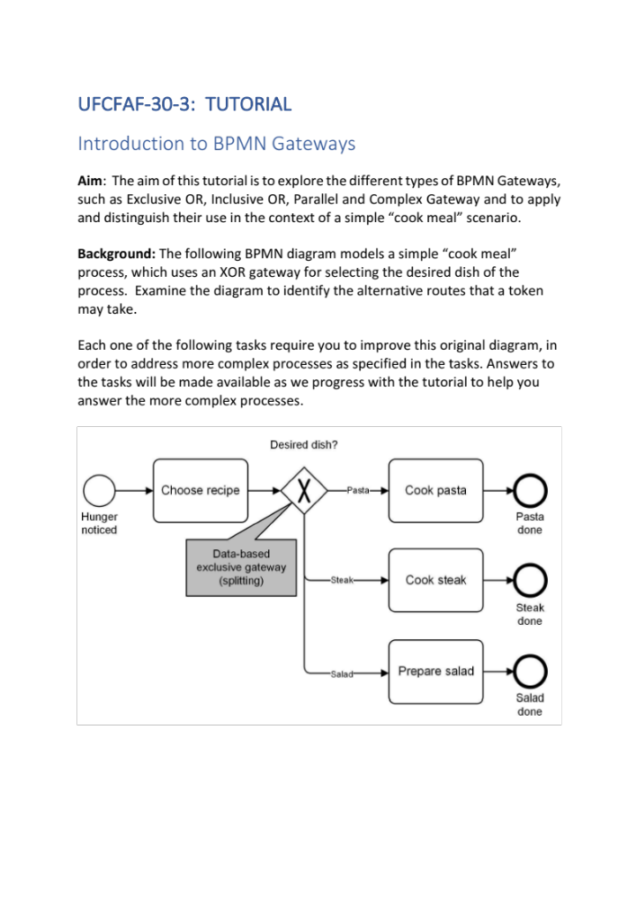

Task A
The above diagram models the three alternative routes of the process, with each option reaching a separate end event. This is not a very fine way of modelling such process. Redesign the process using a merge Gateway leading to a single end-event of the process.

Task B
Improve the diagram of Task A to allow for the task “Prepare salad” to take place before cooking the main meal. Consider including text annotation elements in the diagram, denoting the following times for each task; a) Choose recipe (3 minutes), b) Prepare Salad (10 minutes), c) Cook pasta (15 minutes), d) Cook steak (10 minutes), e) Eat meal (20 minutes)

Task C
The process of Task B can be optimised so you don’t have to waiting 10 minutes for the salad to be prepared before beginning to cook the main meal. Redesign the process in order for the salad to be prepared in parallel with cooking the main meal.

Task D
The above Task C assumes you always have a salad with your main meal. Redesign the above process so you either have a salad with your main meal, or you have your main meal without salad, or even you have salad but no main meal.

Task E
You want to order pizza. You peruse the menu of our favourite supplier, but just for a change, you also look on the Internet. Once you find something you want to try after researching both sources, you order the pizza. How can you model that?

Part 02

Task E
Based on the case study provided, develop the business processes you have identified in the previous tutorial.

